**Setting Up Jenkins Pipeline to Deploy Docker Swarm**

**Step 1:**

* Setup 3 nodes (1 Master and 2 Worker) to create Docker Swarm cluster

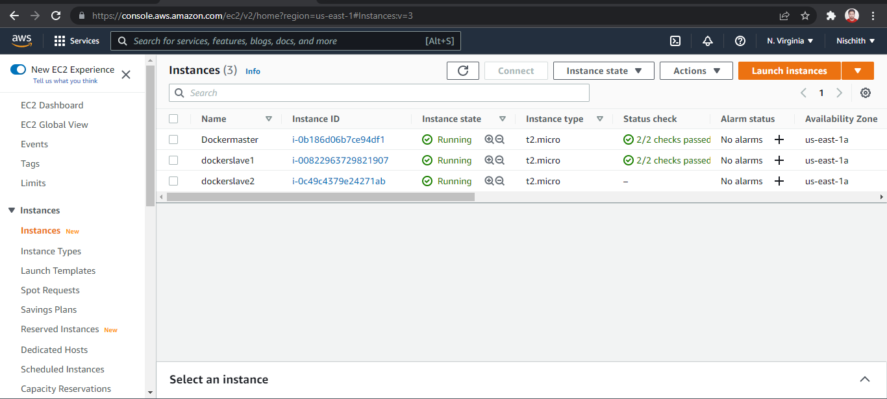

* Do docker yum update –y in all three nodes

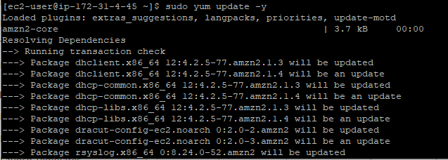

Step 2:

Run these 3 commands in all 3 nodes to install docker

* sudo wget https://get.docker.com/builds/Linux/x86_64/docker-17.05.0-ce.tgz
* sudo tar -xvf docker-17.05.0-ce.tgz
* sudo cp docker/docker* /usr/bin/

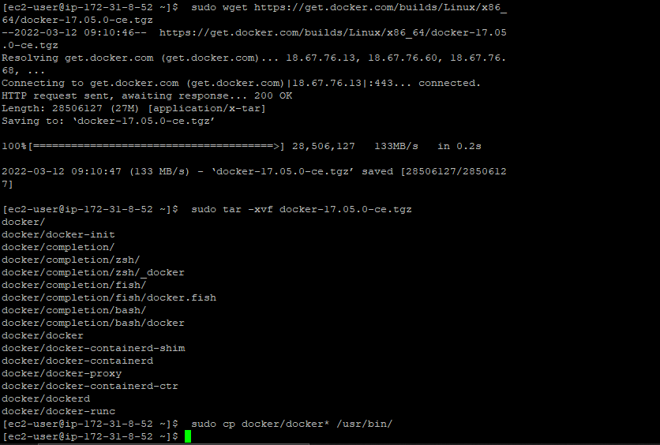

* add this content using cat to install the docker

cat << EOF > docker.service

[Unit]

Description=Docker Application Container Engine

Documentation=http://docs.docker.io

[Service]

ExecStart=/usr/bin/docker daemon

--iptables=false

--ip-masq=false

--host=unix:///var/run/docker.sock

--log-level=error

--storage-driver=overlay2

Restart=on-failure

RestartSec=5

[Install]

WantedBy=multi-user.target

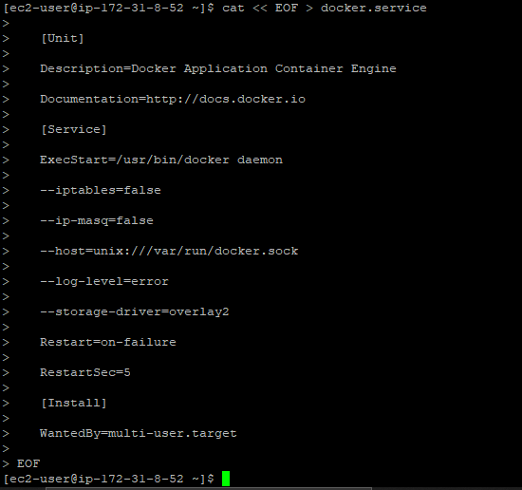

* use these commands to start and enable docker

sudo mv docker.service /etc/systemd/system/

sudo systemctl daemon-reload

sudo systemctl enable docker

sudo systemctl start docker

sudo docker version

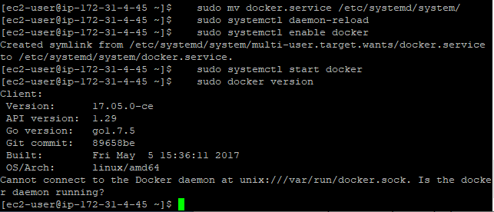

Step 3:

* Enter below command in master node to initialize the swarm.

**sudo docker swarm init --advertise-addr 172.31.4.45**

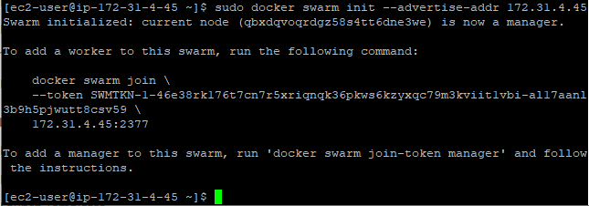

* To check swarm master do

**sudo docker node ls**

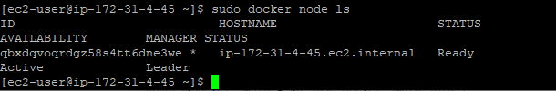

* Do this code in the slave nodes to connect the master and slave node and become a swarm cluster

**docker swarm join \ --token SWMTKN-1-46e38rk176t7cn7r5xriqnqk36pkws6kzyxqc79m3kviit1vbi-al17aanl3b9h5pjwutt8csv59 \ 172.31.4.45:2377**

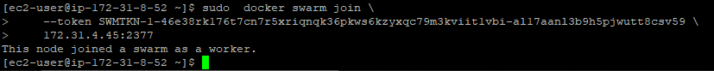

* To check swarm master do

**sudo docker node ls**

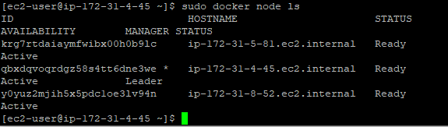

**Step 4:**

* Install Jenkins to docker

**sudo docker container run -d --name myjenkins -p 80:8080 jenkins/jenkins:lts**

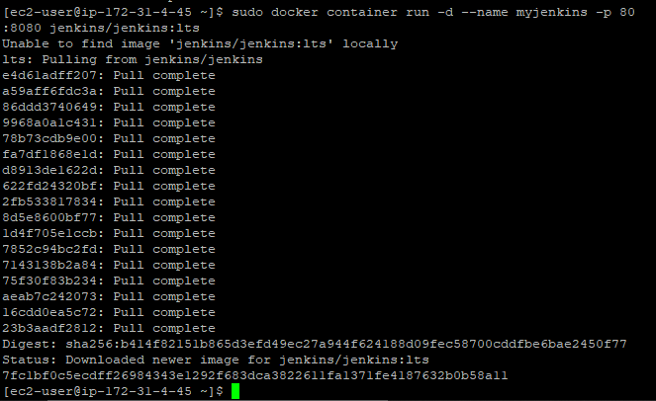

* To see access the Jenkins we need to password that is generated after installing jenkines so do

**docker logs -f myjenkins**





* Use your local host ip address to login to jenkins

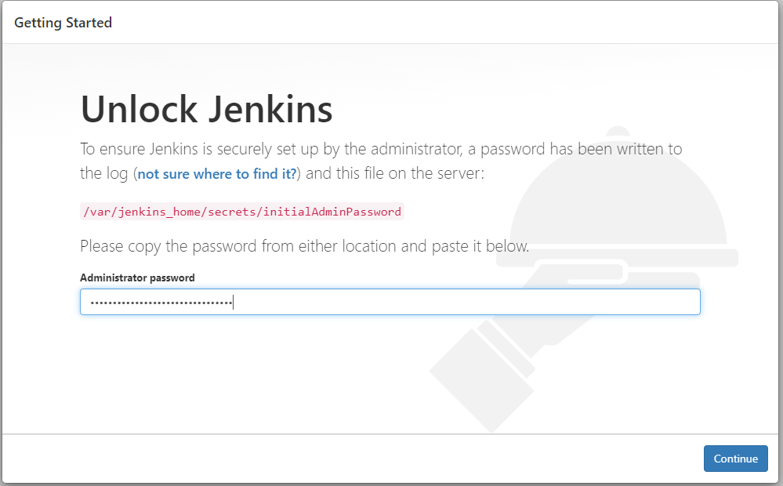

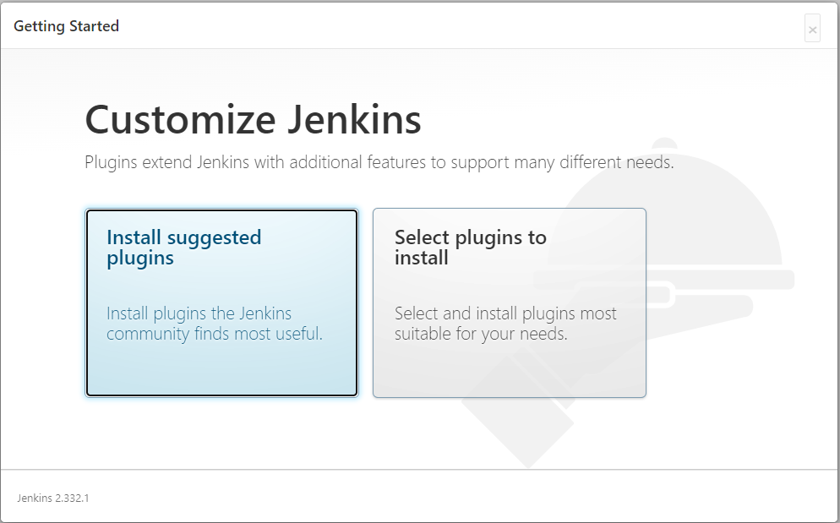

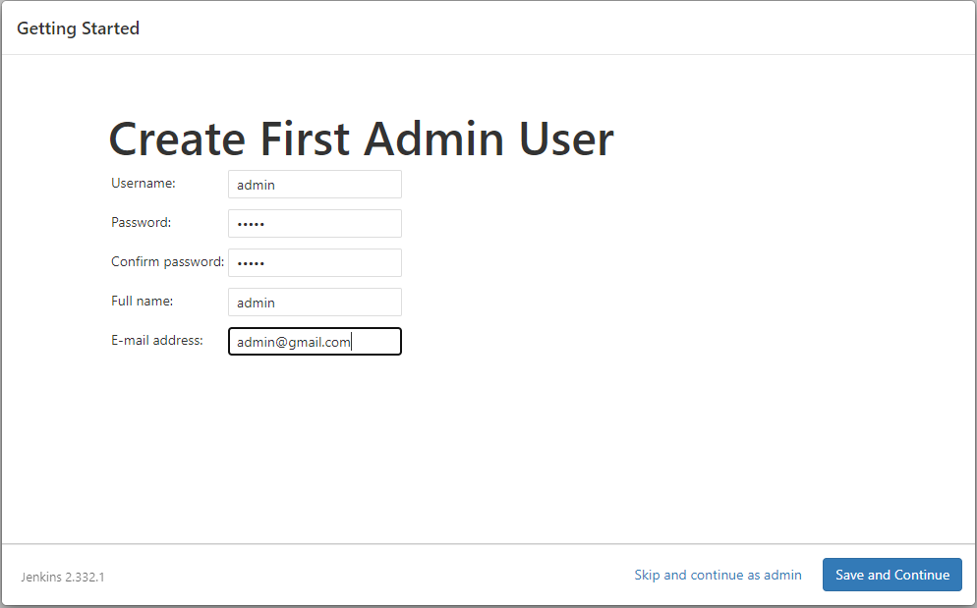

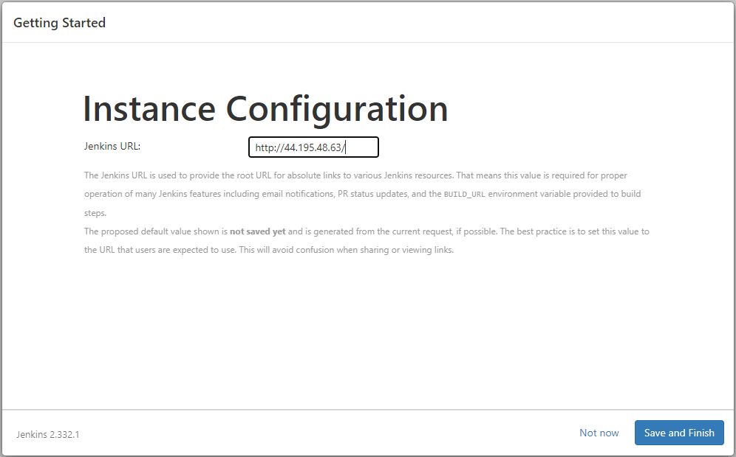

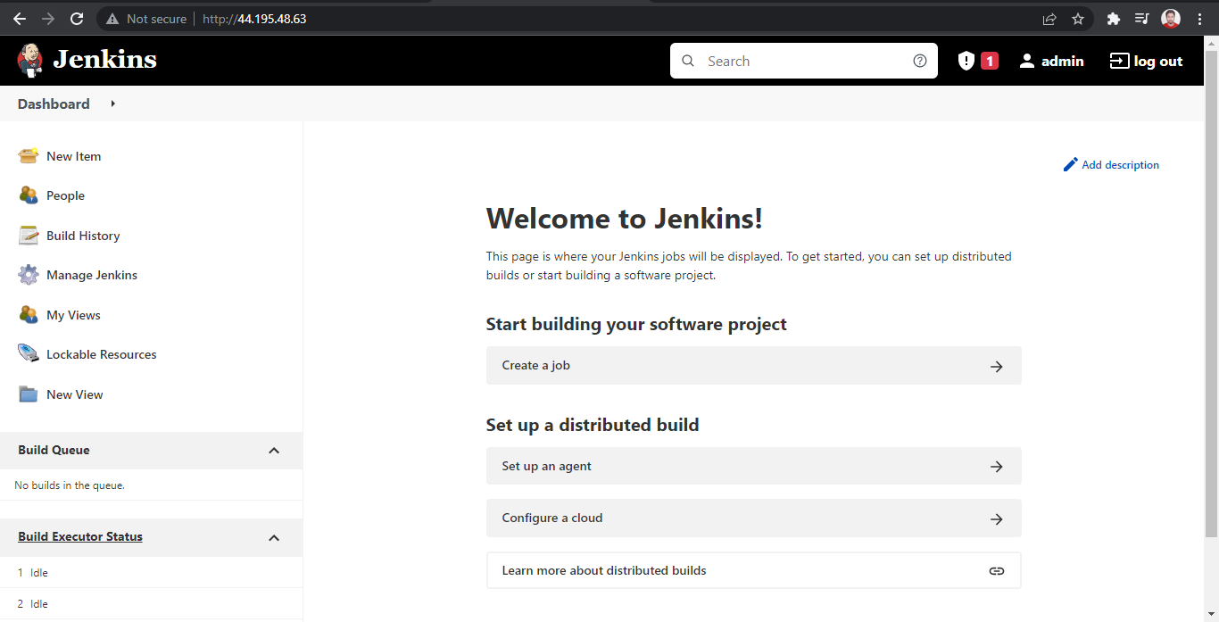

**Step 5:**

Create a Docker secret which will be used be Jenkins swarm agent to connect to jenkins master

* **sudo echo "-master http://10.9.81.107:8080/jenkins -password admin -username admin"**
* **sudo docker secret create jenkins-v1 -**
* **docker service create \**

**--mode=global \**

**--name jenkins-swarm-agent \**

**-e LABELS=docker-prod \**

**--mount "type=bind,source=/var/run/docker.sock,target=/var/run/docker.sock" \**

**--mount "type=bind,source=/tmp/,target=/tmp/" \**

**--secret source=jenkins-v1,target=jenkins \**

**vfabric/jenkins-swarm-agent**

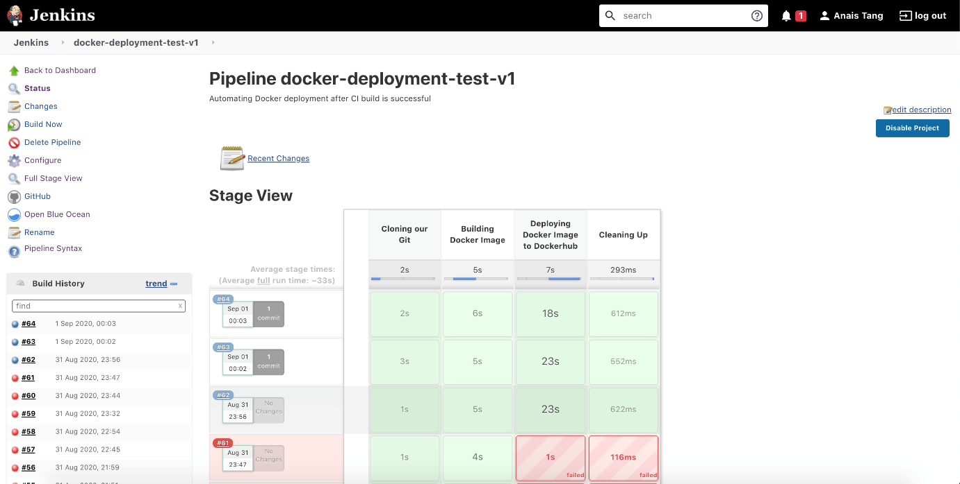

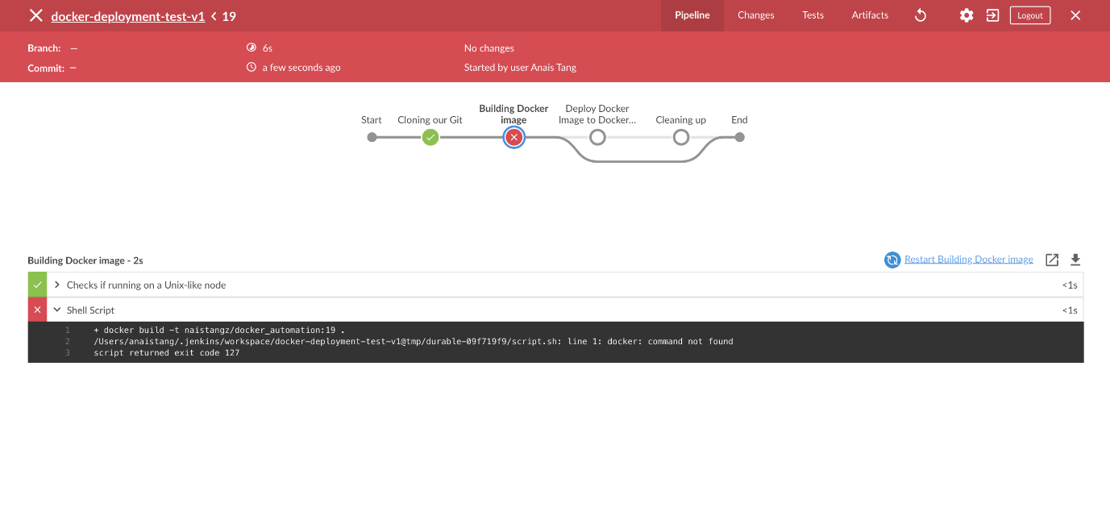

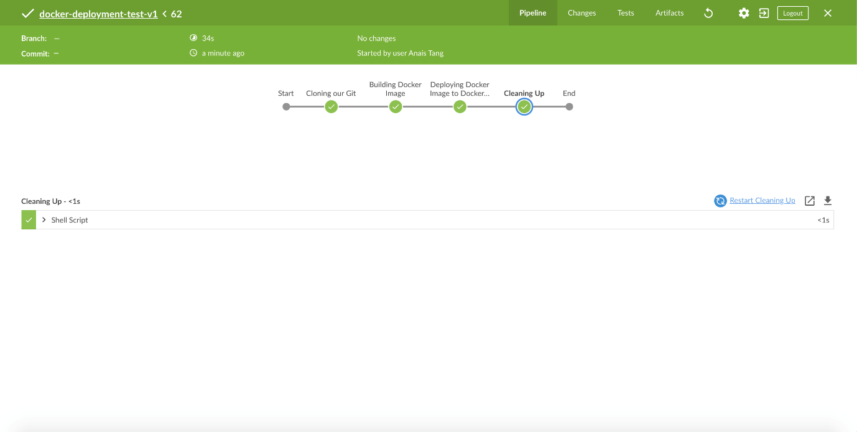

GitHub: https://github.com/Shubham-S07/JenkinsDockerSwarm.git